Student Name:
iGCSE Geography
Course Notes
Population

 |  | Happy | Unsure | It’s a Problem
Describe population distribution and density patterns
Explain why population distribution and density vary
Describe the change of global population over time
Identify and explain the reasons for high and low birth rate
Identify and explain the reasons for high and low death rate
Accurately describe the Demographic Transition Model (DTM)
Recognise the link between the causes of high and low BR and DR to the DTM
Identify examples of countries at each stage of the DTM
Provide evidence that Nigeria has a rapidly increasing population
Provide evidence that Japan has a shrinking population
Calculate rates of Natural Change (BR-DR)
Provide evidence that Nigeria is overpopulated
Provide evidence that Australia is underpopulated
Identify and explain the impacts of bring over and under populated
Describe how the government encourage a population to increase its population size | Pro-natal policy  (have more babies)
Describe how the government encourage a population to reduce its population size | Anti-natal policy (have fewer babies)
Annotate the features of a population pyramid
Describe the features of a population pyramids for youthful, stable and ageing populations
Provide evidence that Japan has an ageing population
Identify the impacts of Japan’s ageing population
Identify the reasons people migrate | Push and pull factors
Identify the impacts of migration on source and destination areas
Explain why people migrate from one country to another and the impacts this has on both countries | Mexico to USA
Exam Question Summary
Topic Breakdown

Question | Mark | To improve I need to ….
End of Unit Assessment | / 25

Population Distribution and Density
Population distribution means –

Population density means –

Stick World Map Here
Describe the distribution of the world’s population using the map above (4)

Natural Population Change
Task 1
Complete the line graph below using the data in Table 1.
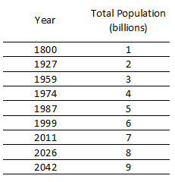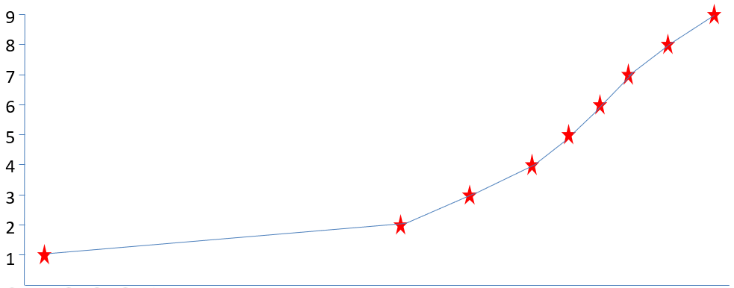
Title =
Year
Total Population (Billions)
1900
1950
2000
1950
1800
Describing the Changes to Global Population
Task 2
Split the graph into three periods of time during which the change to population has changes from the previous time period
Task 3
Annotate what changes have occurred in each time period
Task 4
Describe the changes to word population between 1800 and 2011 (3 marks)

Define the following:
Natural Population Change =
Birth rate =
Death rate =
Infant mortality rate =
Life expectancy =

For global population to increase, what has happened to relationship between BR and DR?

Identify the reasons for high and low birth rate and death rate
High Birth Rate | High Death Rate
Low Birth Rate | Low Death Rate

Task 5
Decide whether the following will lead to high or low birth rate or death rate. Write each scenario in the box you think it applies (some may be written in more than on box)
- Dirty water supply
- High standard of health care
- Need for larger family to earn more
- Poor diet
- War / Conflict
- Raising children has become more expensive
- Knowledge of the use and value of contraception
- Little/no birth control methods available
- High infant mortality rate
- Food is widely available and affordable
- Females are having children later in life and are more career minded
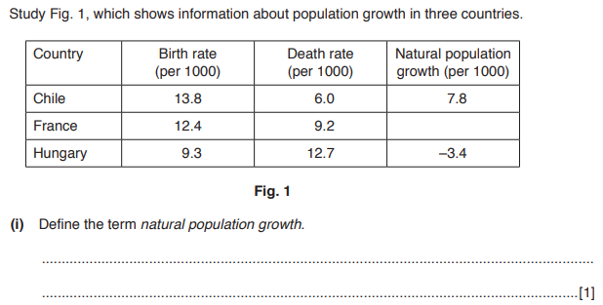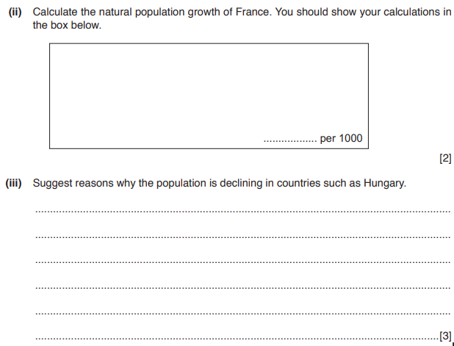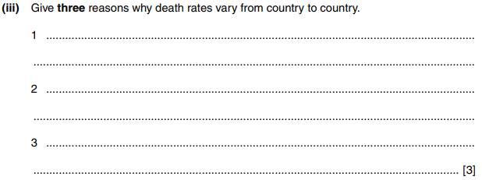
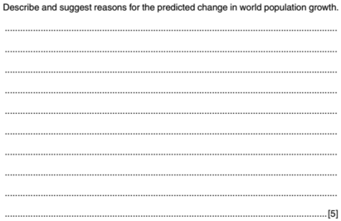
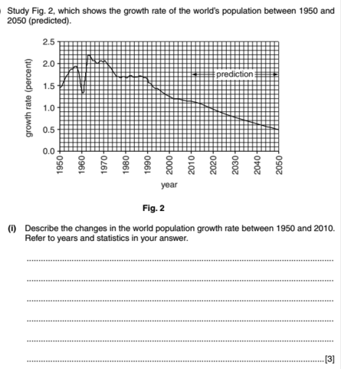

Demographic Transition Model
A study of how population, birth rate and death rate change over time.

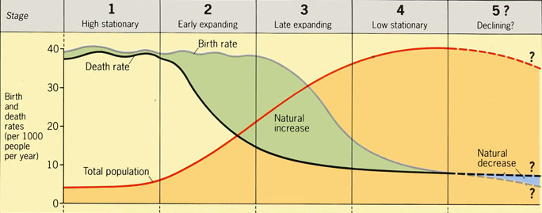

Birth rate
Death rate
Population
Examples
Reasons for change in BR
Reasons for change in DR

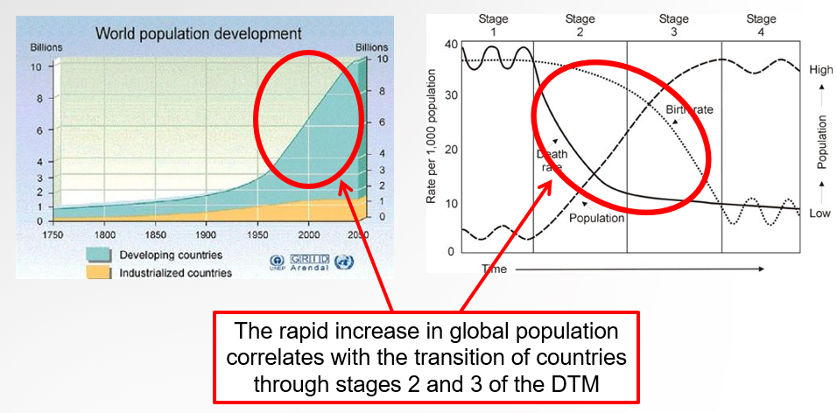
A country with a high rate of population growth
Country:
Evidence:

Explain why The Gambia has a high rate of population growth (factors influencing BR & DR)

A country with a low rate of population growth (or population decline)
Country:
Evidence:

Explain why Japan has a declining population (factors influencing BR & DR)

Population growth rates for 10 selected countries
Country | Continent | LEDC  or MEDC | Birth rate  (per 1000) | Death rate  (per 1000) | Natural change  (+ or -) | Stage of DTM
Angola |  |  | 45 | 25
Bangladesh |  |  | 30 | 8
Ecuador |  |  | 22 | 4
Germany |  |  | 8 | 11
Japan |  |  | 8 | 9
New Zealand |  |  | 14 |  | 6
Philippines |  |  | 26 | 5
Saudi Arabia |  |  | 29 | 3
Somalia |  |  | 44 | 16
UK |  |  |  | 10 | 1
USA |  |  | 14 | 8

Summary:

Over and Under Population
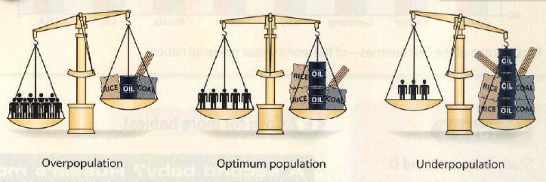
Under-population =

Over-population =

Optimum population =
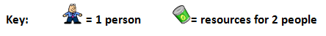

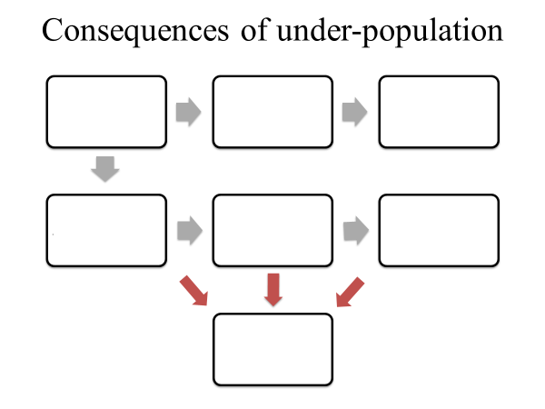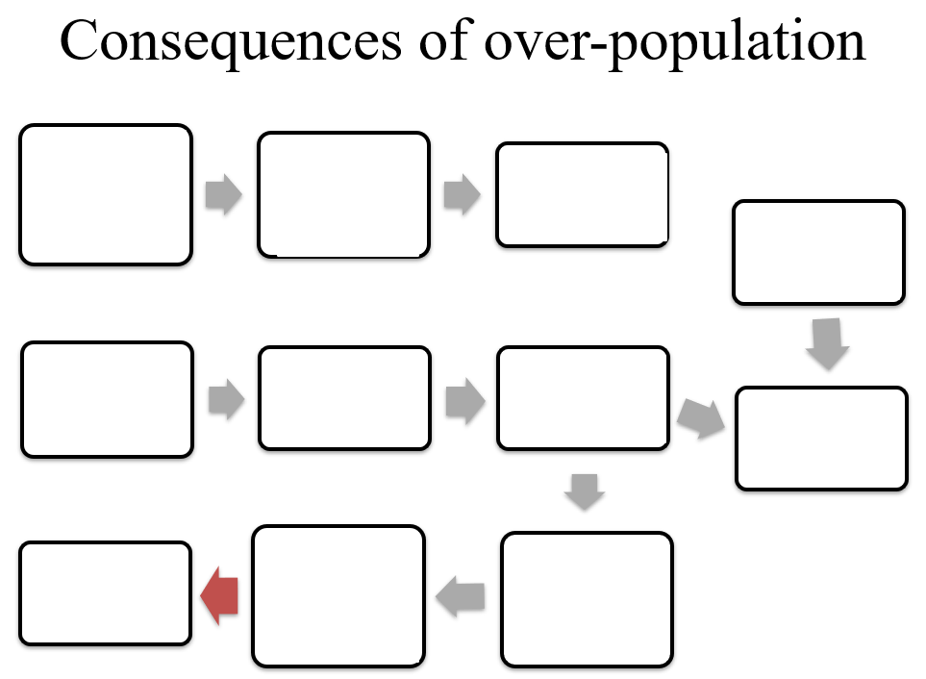
Case Study of Over and Under Populated Countries
 | Under-population (Australia) | Over-Population  (Nigeria)
GDP per Capita (US$) | 41,300 | 6,000
Total Population (millions) | 23 | 181.5
Population density (per km²) | 3 | 195
Value of exports (US$) | 200 bn | 93 bn
Population increase per year (%) | 1.15% | 2.8%
Labour force | 11.6m | 62m
Net migration rate (per 1000) | 6 | -0.22
Years of education | 21 | 9
Literacy rate | 99 | 60
Infant mortality rate (per 1000 live births) | 3 | 72

Population Structure
Population structure is the composition (gender balance and age) of a population. This information is presented using population pyramids.
Population pyramids enable us to interpret BR, DR, Life expectancy, gender balance/imbalances, and variation in the different proportions of different age groups.
Elderly dependent
Young dependent
Dependent population
Working population
Dependency ration

Sketched Population Pyramid
Stage of DTM | Pyramid shape | Reason for shape | Caused by..
 |  | Wide base indicates…  Concave shape indicates…  Narrow top indicates… | This is due to…  This is due to…  This is due to…
 |  | Still a wide base indicating…  Straight sides indicate…  Slightly wider top indicates… | See above  This is due to…  This is due to…
 |  | Narrowing base indicates…  Convex sides indicates…  Wider top indicates… | This is due to…  This is due to…  This is due to…
 |  | Narrower base indicates…  More convex shape indicates…  Widening top indicates… | This is due to…  This is due to…  This is due to…
 |  | Very narrow base indicates…  Top heavy shape indicates… | This is due to…  This is due to…
Impacts of Youthful and Ageing Populations
A young or old population will have considerable impacts on a country. A government will need to make predictions of how their population will change in order to ensure they plan for the future (healthcare, services, schools etc.).

Youthful Population  POSITIVES | Ageing Population  POSITIVES
Youthful Population  NEGATIVES | Ageing Population  NEGATIVES

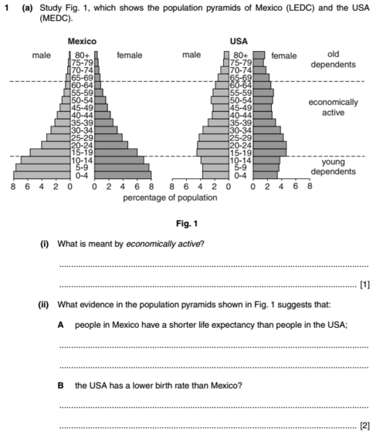
Exam Questions
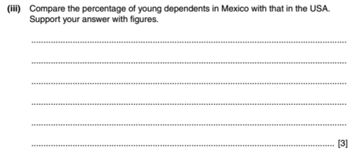

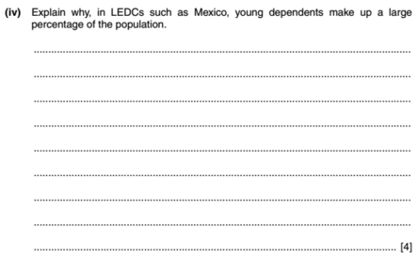
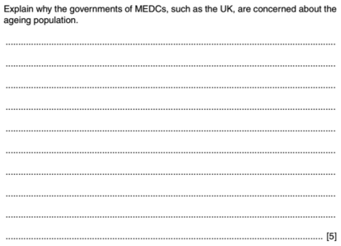

Ageing Population
(Add RGS Ageing Population Info Sheet)
CASE STUDY
Ageing Population in Japan
Using the three population pyramids above, what evidence is there that Japan has an ageing population?
Can you use the terms elderly dependents, youthful population, working population?
Advantages | Disadvantages
- More money spent by retirees  - Increase in volunteering  - Childcare for working parents | - Health costs rise  - Increases taxation for working population  - Schools become underused

Managing Japan’s Ageing Population (pro natal)
- 8 weeks paid leave from work
- Shorter working hours
- A maximum of 24 hours overtime a month
- Economic incentives: e.g the toy company Bandai is offering employees 1 million yen to have a third child and the same for each subsequent child
- Child allowances
- Larger families can get discounts from certain shops
- More time off to have a child

Japan’s Population Statistics
- 1/5 of the population is aged over 65, this is set to be 1/3 by 2023
- In 1975 the birth rate was 19
- In 2006 the birth rate was 6.3
- fertility rate = 1.25

Population Structure Exam Questions

