Student Name:
iGCSE Geography
Course Notes

Coasts

Coasts Topic Summary

 |  | Happy | Unsure | It’s a Problem
Know how waves are generated
Describe the characteristics of waves | Constructive wave  Destructive wave
Describe and explain how the sea and wind erode the coastline | Attrition  Abrasion  Hydraulic action  Corrosion (solution)
Describe and explain how the sea and wind transports sediment (including longshore drift) | Traction  Saltation  Suspension  Solution
Describe and explain how the sea and wind deposits sediment
Describe and explain the formation of landforms associated with the processes (erosion, deposition and transportation)  Know named examples for each | Wave cut notch (WCN)  Wave cut platform (WCP)  Cave, arch, stack and stump (CASS)  Bays and headlands  Beaches  Spits  Coastal sand dunes
Describe the characteristics of coral reefs

Describe the conditions needed for the formation of coral reefs
Explain how fringing reefs, barrier reefs and atolls form
Describe the differences between fringing reef, barrier reef and atolls
Describe the characteristics of mangrove swamps
Describe the conditions needed for the formation of mangrove swamps
Describe the opportunities created by a selected coastline | Tourism topic Year 11
Describe the hazards that coastlines present  (Must include impacts) | Erosion - Holderness, Happisburgh  Tropical Storms
Describe and explain hard and soft engineering management techniques
Explain the management techniques used for a selected location | Holderness

Exam Question Summary

Question | Mark | To improve I need to ….
End of Unit Assessment | / 25

Waves
A wave is a ….

The features of a wave

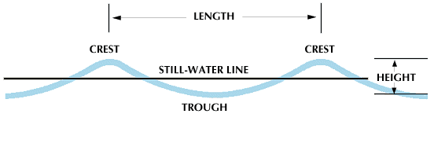
<
Waves are generated by the frictional drag of the wind across the surface of the sea. The size and strength of waves depends on three factors:

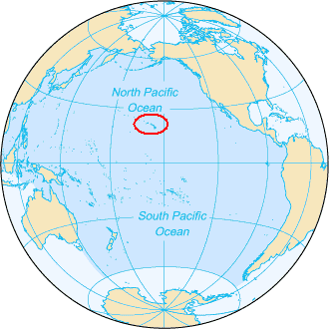
Looking at the two maps to the right. Explain why Hawaii usually has bigger waves than Italy.

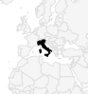
Constructive and Destructive Waves

As waves approach the shore, the depth of the sea becomes _______________, causing the waves to __________ in height.
The type of wave is influenced by how quickly the ____________ of the seafloor changes.
More gradual changes in the depth cause waves to ________________ build in height. These are called Constructive Waves.
If the seabed rises more steeply, ___________ waves form called Destructive Waves.
When a wave breaks, the water continues to travel up the beach called the _______________.
Once the wave no longer has enough energy to move the water up the beach, it flows back down the beach called the _______________________.
gradually swash shallower taller
backwash grow depth

Watch the two videos of Constructive and Destructive waves and complete the table of characteristics below:
Characteristic | Constructive Wave | Destructive Wave
Swash
Backwash
Beach slope
Wave strength
Wave height
Wave frequency

Draw a simple sketch of a constructive and destructive wave along with the beach profile they create in the space below:
Constructive wave | Destructive wave

Applying Your Knowledge: Exam Questions
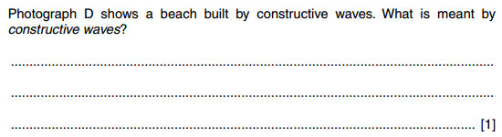
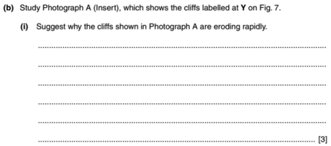
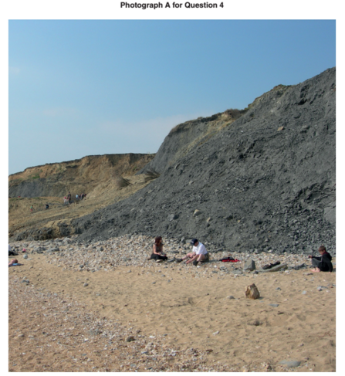

-------------------------------------------------------------------------------------------------------------------------------------------------------------------------------------------------------------------------------------------------------------------------------------------------------------------------------------------------------------------------------------------------------------------------------------- (3)
Coastal Processes
EROSION
How are coastlines reshaped?
In this section you will recap the erosion, transportation and deposition processes that you have already learnt in the Rivers topic.
Coastal Erosion
What is erosion?

Identify and explain each of the four erosion processes represented by each cartoon:
 | Erosion type | Explanation
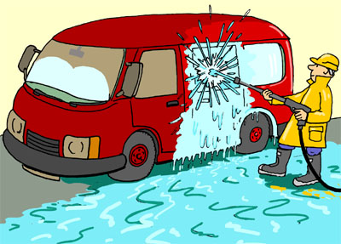
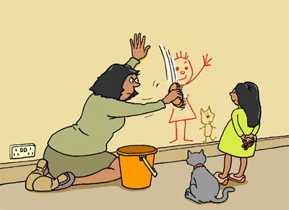
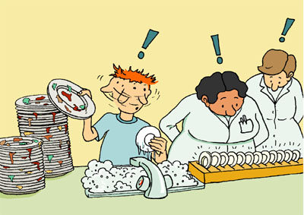

Why are some coastlines more vulnerable to erosion than other coastlines?

Erosion Landforms

Cliff =

- Why do cliffs form?

- What are the features of a cliff?

Exam Question
Describe the main features of the landform shown in Photo below (4 marks)
Stick Cliff Photo Here

____________________________________________________________________________________________________________________________________________________________________________________________________________________________________________________________________________________________________________________________________________________________

Erosion Landforms

W C N =
Stick photo here

Describe the appearance of the cliff in the photograph
_____________________________________________
_____________________________________________
_____________________________________________
_____________________________________________
_____________________________________________
Explain how the wave cut notch has formed (include the following words)
abrasion hydraulic action hitting high water mark
Low water mark waves

The waves strike the rock/cliff
These processes undercut the rock/cliff causing a wave cut notch to form
Hydraulic action and abrasion wear away the rock
Erosion occurs between the high and low water mark

Erosion Landforms

W C P =
As erosion continues, the wave cut notch becomes deeper and eventually the material above the notch will collapse. If this is a cliff line, then the cliff will retreat inland. This will leave behind a platform of hard rock that was once part of the cliff but is no only exposed at low tide.
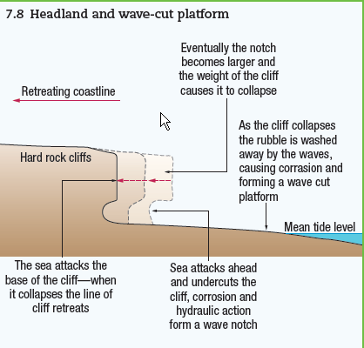

Use annotations on the photo below to explain the formation of a wave cut platform

Stick WCP Photo here
Erosion Landforms

Bay =

Headland =

Box 1 shows a stretch of coastline that is described as discordant, meaning the bands of hard and soft rock run perpendicular to the coast (at 90º).
Over time erosion will change the shape of this coastline. Draw the shape of the same stretch of coastline after 100 years of erosion.
Box 1 Box 2

Describe the changes to the coastline:

Explain why you think these changes will occur:

Erosion Landforms

C A S S =

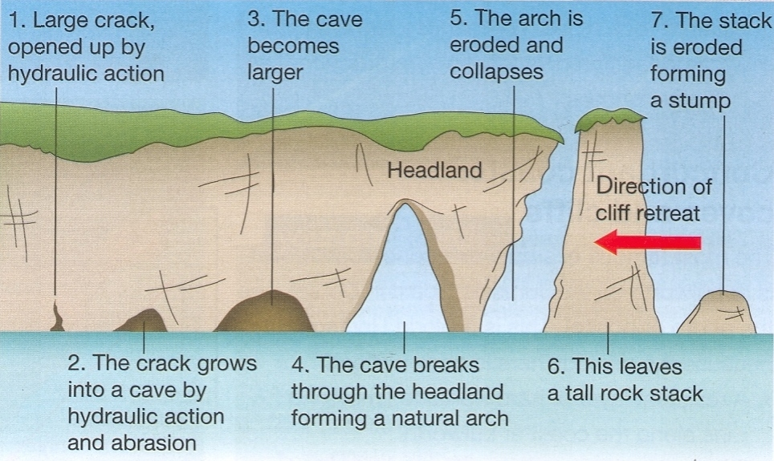
Complete the following questions:
- Where are caves, arches, stacks & stumps likely to form along a coastline?

- Why are caves, arches, stacks & stumps likely to form at these locations?

- What sort of rock type is needed for caves, arches, stacks & stump formation?

- Why might some caves not form an arch?

Describe and explain the features of coastal landforms resulting from erosion
Wave cut notch
Wave cut platform
Bay and headland
Cave, arch, stack and stump

Create a revision activity for one or more of the above erosional features
(crossword, card sequencing, diagram exercise, cartoon sequence, animation)

Coastal Transportation

Coastal environments can be described as dynamic; they are continuously changing. It is not only erosion that causes these changes but the movement of material as well: transportation.
Task
The four methods of transportation are identified below.
Draw a diagram for each transportation method and explain why it occurs. This could refer sediment size or energy levels required.
Traction
Saltation
Suspension
Solution

What are the two factors that will influence which of the above transportation methods is likely to take place?

Longshore Drift
Longshore drift is …

Ingredients for Longshore Drift

Sequencing Longshore Drift

Coastal Deposition

- To deposit means …
_______________________________________________________________________________________

- For deposition to occur what must already be happening?
_______________________________________________________________________________________

- For deposition to occur what must change?
_______________________________________________________________________________________

- Identify four reasons why this would occur

Exam Questions
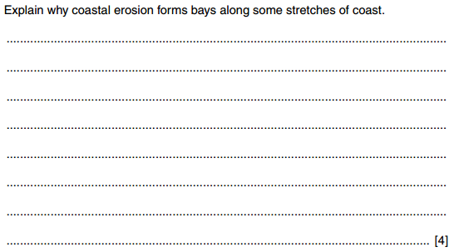

Depositional Landforms
- Spit
A spit is ….

Describe the appearance of Hurst Castle Spit

Using your map skills and knowledge of longshore drift, explain how Hurst Castle Spit is formed.

- Beach
A beach is ….

Where does beach material come from?

What are the features of a beach?

Sand Dunes

Mangrove Swamps

What are Mangroves and where are they?
Mngrvs (gnrlly) r trs nd shrbs tht grw n sln (brcksh) cstl hbtts n th trpcs nd sbtrpcs.
Thy r fnd n ntrtdl zns lng strs nd mrn shrlns.

_______________________________________________________________________________________
_______________________________________________________________________________________
_______________________________________________________________________________________
_______________________________________________________________________________________

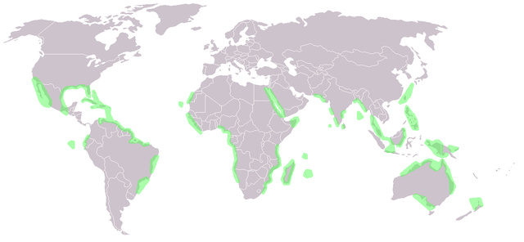

Thy fc prblms f frqnt sbmrsn, sln nvrnmnt tht trs nd shrbs gnrlly cnnt srvv nd lck f xygn.
Dffrnt plnts hv dffrnt wys f dlng wth ths prblms
_______________________________________________________________________________________
_______________________________________________________________________________________
_______________________________________________________________________________________
_______________________________________________________________________________________

How mangroves adapt to their environment
- Salty conditions

- Lack of oxygenated waters

- Nutrients

What are the benefits of mangroves forest?
Watch video and read through the BBC article

Coral Reefs
What is coral?

What is needed for it to form?

Where does it form (distribution)?

Threats to Coral Reefs

Coastal Opportunities
- Identify / describe three opportunities coastal environments offer

- Explain these three opportunities

- State three located examples where these coastal opportunities exist

Exam Questions
Describe and explain the conditions required for the development of a coral reef (5 marks)

For a location you have studied, explain the opportunities the coastline presents (7 marks)

Coastal Hazards

